**USER INTERFACE DESIGN**

**EXERCISE 6**

**UI design using RAD model and documentation**

In this exercise there are 4 phases. In the phase – 2 we will be using the tool called Axure rp (<https://www.axure.com/>).

This exercise mainly focuses on creating a prototype with respect to the RAD model and a documentation for support for any issues.

**What is RAD model?**

RAD – Rapid Application Development. It a model used for completing a prototype model ‘very quickly’. If the requirements and ideas are clear for the developer, RAD model is best to go for as it finishes the job instantly and produce fruitful results.

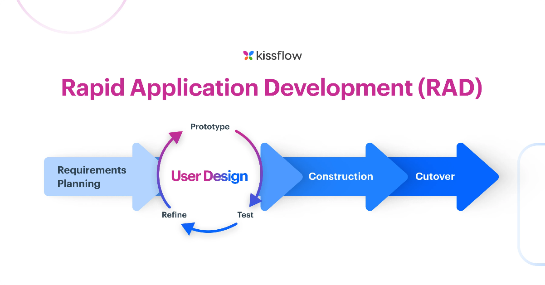

Fig. 1. RAD model diagram

**Phase 1: - Requirements planning.**

In this phase we will be discussing about the requirements necessary for the user so that the developer can implement in his prototype. The developer is expected to know the requirements before starting his prototype.

Navigation: Home, Product Categories, Product Details, Cart, Checkout, Order Confirmation, Order History.

This is the manner of the Navigation which will help the user know how to get to a product and purchase it successfully.

User actions: Browsing, Searching, Adding to Cart, Checkout, Tracking Orders

These are the actions which are mostly like expected to be performed by the user in the given prototype.

User stories: One of the User, wishes to have the application to be an easy navigable and approachable to enhance user experience.

Another user would want the application to be error free, meaning that no bugs should be there and should have a smooth experience.

Like this many users have many concerns on how they view the app to be. So, the developer has to listen to them and plan the requirements accordingly.

**Phase 2: - User design**

In this phase, the designer has to design the app the way it best suits the user and keep them engaged and have a pleasant experience.

This is the sample design for an online shopping page:

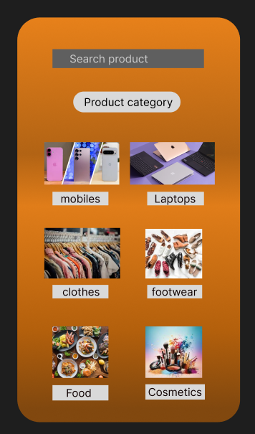

Fig. 2.1. Home page

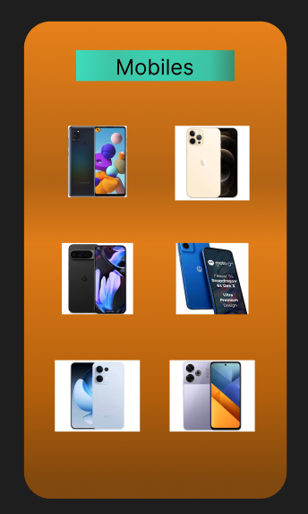

Fig. 2.2. Mobiles page

Here the user finds it easy to navigate to different pages. From the Fig.1. We can see that each category of the shop is listed in a very visible and easy access manner and also display a picture for the user to find it easier to navigate to. It makes the user revisit the app often as well.

The user can also search for a specific product they are looking for. So it makes the user engaged and reduces human error as well.

In the Fig.2. We can see a specific category “mobile” where different brands of mobiles are listed. Upon clicking one of the brands displayed the user will be navigated to different models of that brand mobile. So this way its pretty easy for the user to know what to do and makes it faster/rapid as well. Likewise other categories work too.

**Phase 3: - Construction**

In this phase additional details like interactive prototypes are made, this prototype will be given to some users to get the feedback for any further change.

Thus, this process will be an iterative one.

Once this is done, a testing is done to the application in order to check if everything works smoothly before releasing it to the public people.

This involves user engagement as the prototype will be tested by some users only along with the designer with them to know what all changes have to be made to the application.

The iterative testing and altering part go through these steps:

○ Preview the prototype using the Preview button.

○ Gather feedback from users and stakeholders.

○ Make necessary adjustments based on feedback.

Once these are done, we will move onto the final phase.

**Phase 4: - Cutover**

In this phase the design is finalized along with its interactions.

Thereby the application is exported in the form of an HTML or into Axure cloud to set it ready to release publicly.

Certain training sessions are to be conducted upon release of the application amongst the users to familiarize with the new interface.

This will help build a strong trust in using the app and promote the app even further.

Once this is done, present a documentation for support if any issue is faced by any user. This support is necessary to rectify the problem immediately. Sometimes the user themselves can rectify it, hence the document is provided (it works a like a user manual)